Day 7 Assignmemt

Get node master
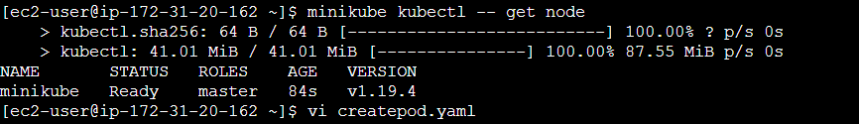
Create a yaml file to get pod

Pod create with name of httpd
Tained the node
Now deleted the httpd pod and created after tained the status is showing pending

remove the tained the status in showing running
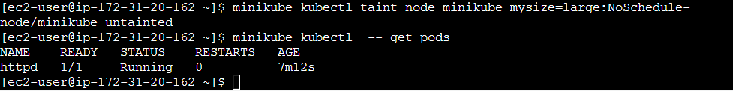
Added the label in node size=large
delete the httpd pod to create again
nodeSelector size: "small" but in label we have given large that's why showing pending

Now given size:large finally running
